Wenzao Ursuline University of Languages
Graduate Student Thesis Formatting
I. Sequence of items in the thesis
1. Front cover | 6. Abstract in English | 11. Thesis text
2. Title page | 7. Acknowledgements or  preface | 12. Bibliography
3. Thesis oral defense approval  form | 8. Table of contents | 13. Appendices
4. Thesis/dissertation release  form | 9.List of tables | 14. Curriculum Vitae or résumé（optional）
5. Abstract in Chinese | 10. List of figures | 15. Back cover

II. Formatting requirements
  - Front cover: See Appendix 1. Include name of graduate institute, degree, thesis title, thesis advisor, name of graduate student, and year and month of submission.
  - Title page: Include title of thesis in Chinese and English, name of graduate student and thesis advisor in Chinese and English, name of graduate institute, degree, location, and year and month of submission. See Appendix 2.
  - Oral defense approval: See Appendix 3.
  - Thesis/Dissertation Release Form: See Appendix 4 for National Central Library Electronic Thesis/Dissertation Release Form.
  - Abstract in Chinese and English: The abstract should state purpose of the study, source of data, research methodology and results. It should be approximately 300-500 and limited to one page. A version in Chinese and a version in English should be included. See Appendix 5 and 6 for layout instructions.
  - Size and paper: Use paper measuring 210 mm by 297 mm of A4 size. Use cardboard or linen paper of 150-lb or higher weight for front and back covers in the color designated by the graduate institute.
  - Page layout: Leave a top margin of 2.5 cm, left margin of 3 cm, right margin of 2.5 cm, and a bottom margin of 2.5 cm. Place the page number on the center of the page 1.5 cm from the bottom of the page.
  - Text formatting: If the text is written in Chinese, it should be written horizontally from left to right. Text in a foreign language should be placed within parentheses. The Chinese font BiauKai should be used in the following sizes: 20 point for chapter headings, 18 point for section headings, 16 point for subsection headings, 14 point for subsubsection headings, and 12 point for main text. Use line spacing of 1.5. Use BiauKai also for the cover page. If the text is written in English, use the font Times New Roman in the same sizes as specified for text in Chinese. Use Times New Roman for the cover page, too.
  - Page numbers:
- Use sequential Roman numerals i，ii，iii… to number the pages from the abstract in Chinese to the list of figures.
- Use sequential Arabic numbers 1，2，3… to number the pages of the thesis from chapter 1 to the appendices.
  - Binding: Bind the thesis on the left side and print on its spine the year of graduation, degree level, title of thesis, name of the university, name of the graduate institute and name of the author. (See Appendix 7.)
  - Online submission: Upload the complete text and bibliography of the thesis according to the University’s regulations.
  - Filing: Once approval is obtained after the oral defense, submit at least 2 copies of the thesis. Other regulations may be prescribed by individual graduate institutes.

Appendix 1. Cover page layout

3 cm margin
4 cm margin
文藻外語大學外語文教事業發展研究所碩士學位論文

BiauKai 18 pt font

3.5 cm margin
2.5 cm margin
Title (Chinese: BiauKai 20 pt font)

BiauKai 14 pt font
指導教授:○○○ 博士
研 究 生:○○○ 撰寫

中 華 民 國 98 年 6 月

3 cm margin

Appendix 2-1. Title page template in Chinese

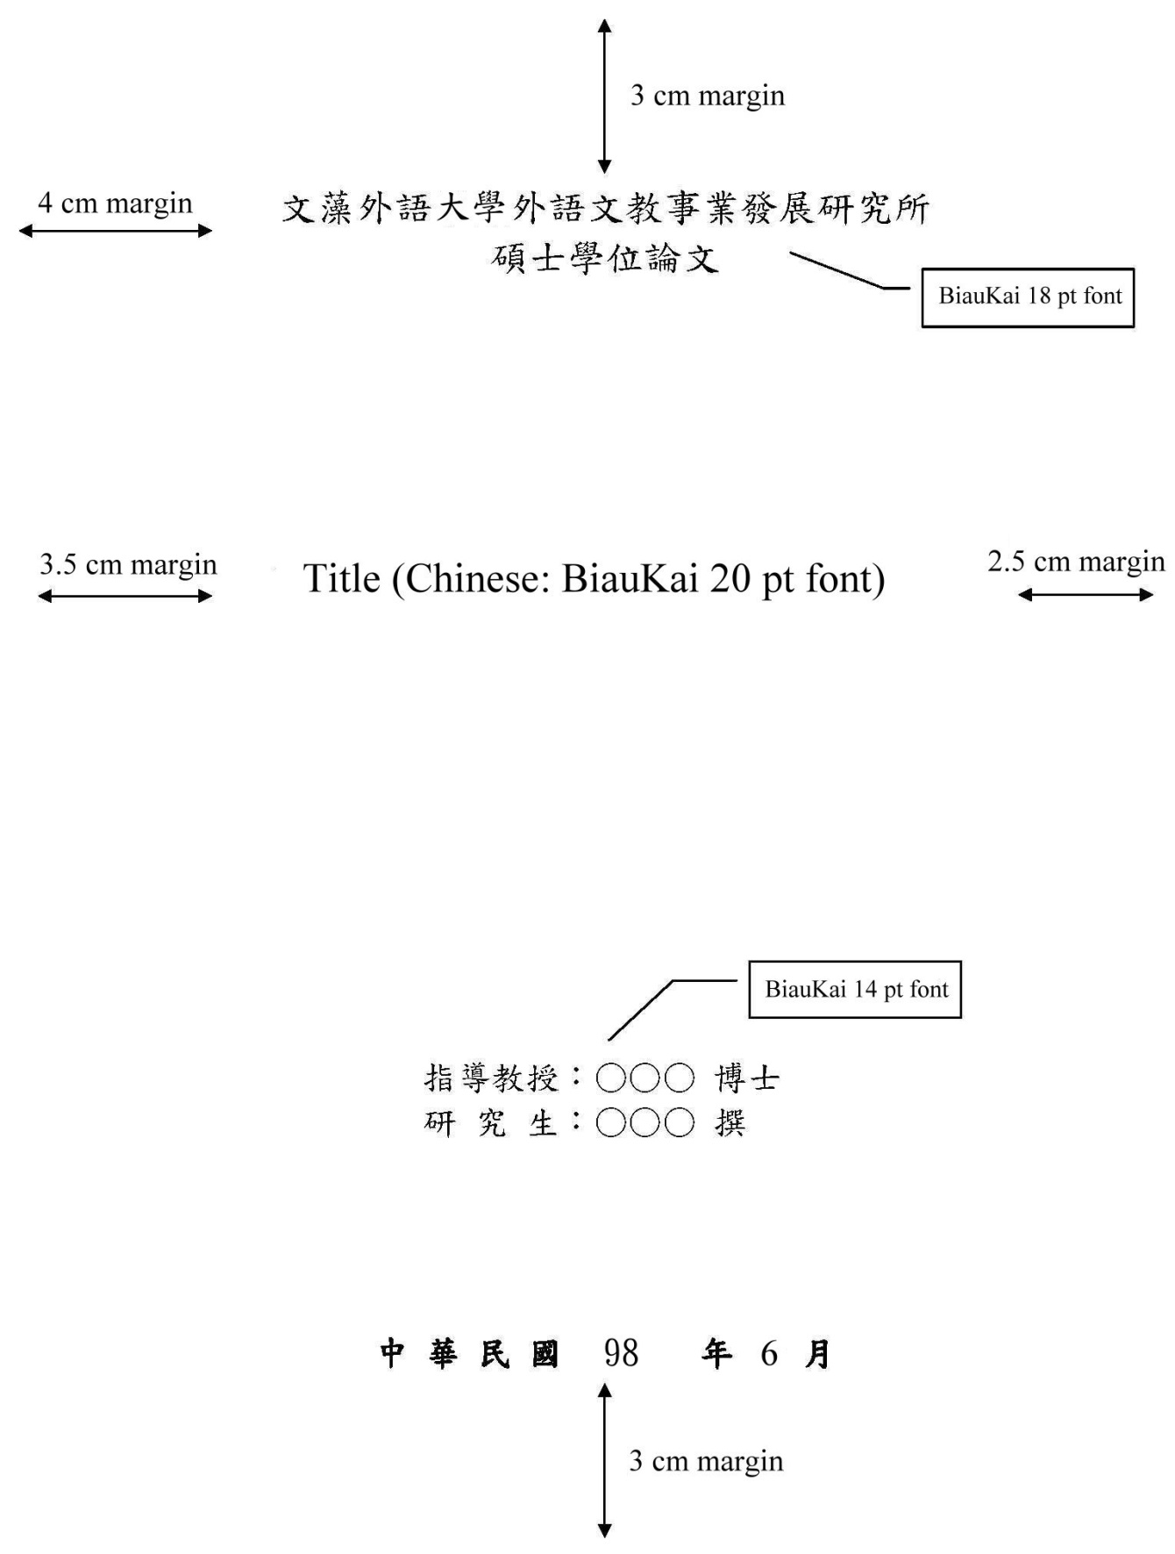

Appendix 2-2. Title page template in English

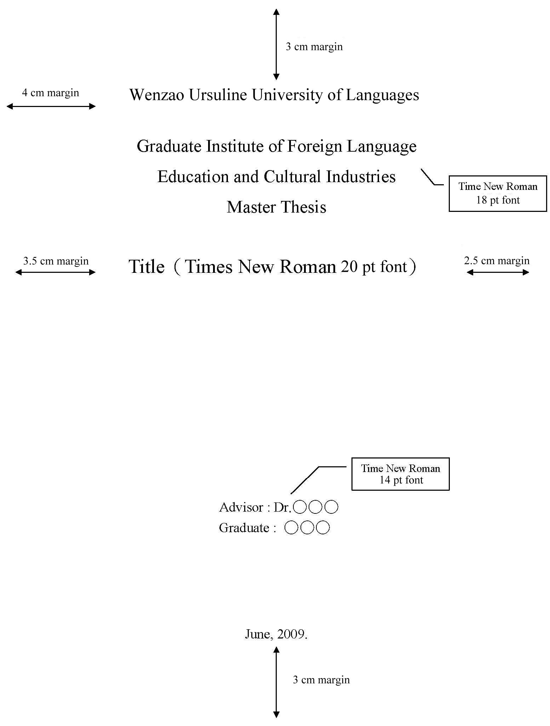
Appendix 3. Thesis oral defense approval form

Wenzao Ursuline University of Languages
Thesis Oral Defense Approval Form

The student __________ enrolled in the Master’s program in ____________ has satisfactorily passed the oral defense of the thesis ____________.

Oral defense committee members
Advisor
Dean of Graduate Institute

Date: yyyy mm dd
Appendix 4. National Central Library Electronic Thesis/Dissertation Release Form
National Central Library Electronic Thesis/Dissertation Release Form

This release covers the thesis/dissertation written by ________________ as part of the author’s master’s/doctorate degree obtained at the Graduate Institute __________ of Wenzao Ursuline University of Languages in the _____ semester of the ______ academic year.

Thesis/dissertation Title:
Advisor:
I hereby grant the National Central Library the non-exclusive, royalty-free right to reproduce and display the full text (including the abstract) of the thesis or dissertation referred to above in the form of microfiche, CD or other digital format without limit of location, time and frequency for readers to search, read, download or print for personal, non-profit purposes.

Select authorization granted
◻ | Make public immediately.
◻ | This thesis/dissertation is part of the documentation submitted for a patent application to the Intellectual Property Office of the Ministry of Economic Affairs.  (Ref. No.: )  Please make it public or available on the Internet after dd/mm/yyyy
◻ | Because this thesis/dissertation has not been published, please do not make it public or available on the Internet until dd/mm/yyyy ___________.
◻ | Do not make public.

Author:
ID number:
E-mail:
Signature:
Date: yyyy mm dd
Appendix 5. Abstract in Chinese

××××××××××××××（Title in Chinese）××××××××××××××
Abstract
______________________________________________________________
______________________________________________________________
______________________________________________________________
______________________________________________________________
______________________________________________________________
______________________________________________________________

Keywords:
Appendix 6. Abstract in English

–––––––（Title in English）–––––––
–––––––––––––––––––––––––––––––––––––––––
ABSTRACT
______________________________________________________________
______________________________________________________________
______________________________________________________________
______________________________________________________________
______________________________________________________________
______________________________________________________________

Keywords

Appendix 7. Printing on the spine


